High Achiever – Analysing Magazines
Reaching for the stars – how to get an A* with your analysis
- The images

Analyse everything about the image
- Costume
- Make up
- Hair
- Body language
- Facial expressions
- Positioning on the page
- Connection with the audience

- The Layout
Analyse all elements of the layout
- Positioning of masthead/headline
- Positioning of coverlines (only on the cover!)
- Positioning of text
- Positioning of images
- Colour
- Font choices
- Blocks/ shapes containing text or images
- Number and size of columns
- Crossheads
- Straplines

- The Language
Analyse as many different examples of literary techniques that you can find
- Puns
- Rhyme
- Alliteration
- Rhetorical questions
- Repetition
- Internal rhyme
- Colloquial language

- For each point think about the connotations of the presentation. For example – the hair looks wild and is blown across the face – why? What does this suggest about the model’s attitude/ beliefs/ personality?
- Consider what these presentational methods tell us about the magazine – what kind of magazine is it? Who does it target and how does the image fit this audience and institution? – do some research!

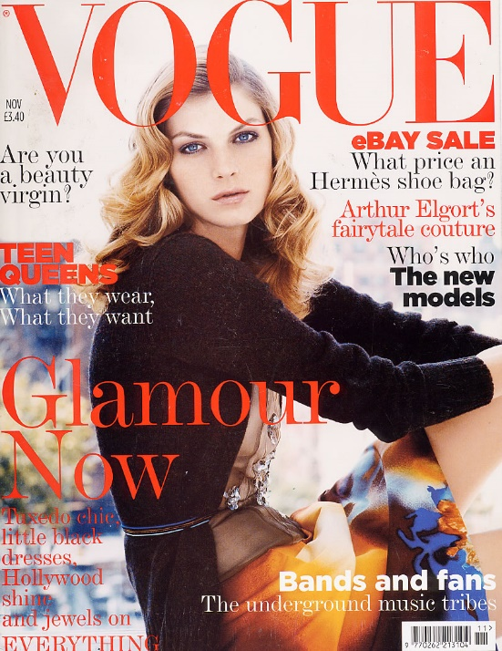
SOME EXAMPLES
Coverline: Teen Queens is in bold red sans-serif font to reflect the youthful nature of this article. Rhyme makes it catchier. The subheading to the coverline uses repetition and alliteration of ‘w’ to suggest that the reader might want to know more about teenagers – perhaps aiming this article at their mothers?
These examples give you an idea of A* grade analysis. There are more comments that could be added (using the prompts above) about the images and language use. Try to use sophisticated vocabulary to explain your ideas and justify your points.
LAYOUT: coverlines are placed on left and right sides of page, but not over model’s face. Only 3 colours are used for the coverlines which is typical of a magazine to maintain a colour scheme. More prominent coverlines are larger or bolder
Date and title are placed next to the masthead and barcode is at the bottom, so as not to detract from the main image or coverlines. Vogue typically only uses one main image and does not include a puff as the brand name in the masthead is enough to sell the magazine.
Model is seated sideways to the camera with her head turned to face the reader. Head is slightly slanted and mouth is open to suggest a dreamy, wistful mood. This is emphasised by the shallow focus which means the background mise en scene is out of focus.
Masthead is in sans-serif font which gives the impression of tradition and sophistication. Vogue has been around since 1892 so has a strong reputation as a fashion magazine. It uses its name as its unique selling point –so name is placed over model’s head

