Language use in contents pages
How is language used in the following section from a contents page?
2
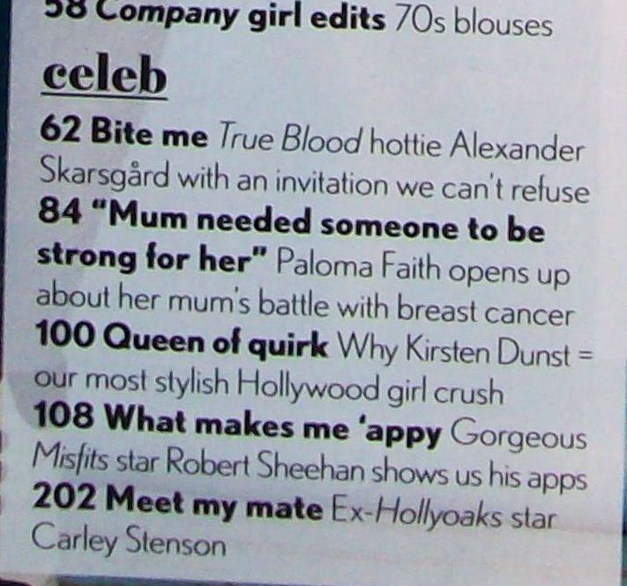
1
3
4
5
6

