PHOTOSHOP TUTORIAL
ESSENTIAL SKILLS
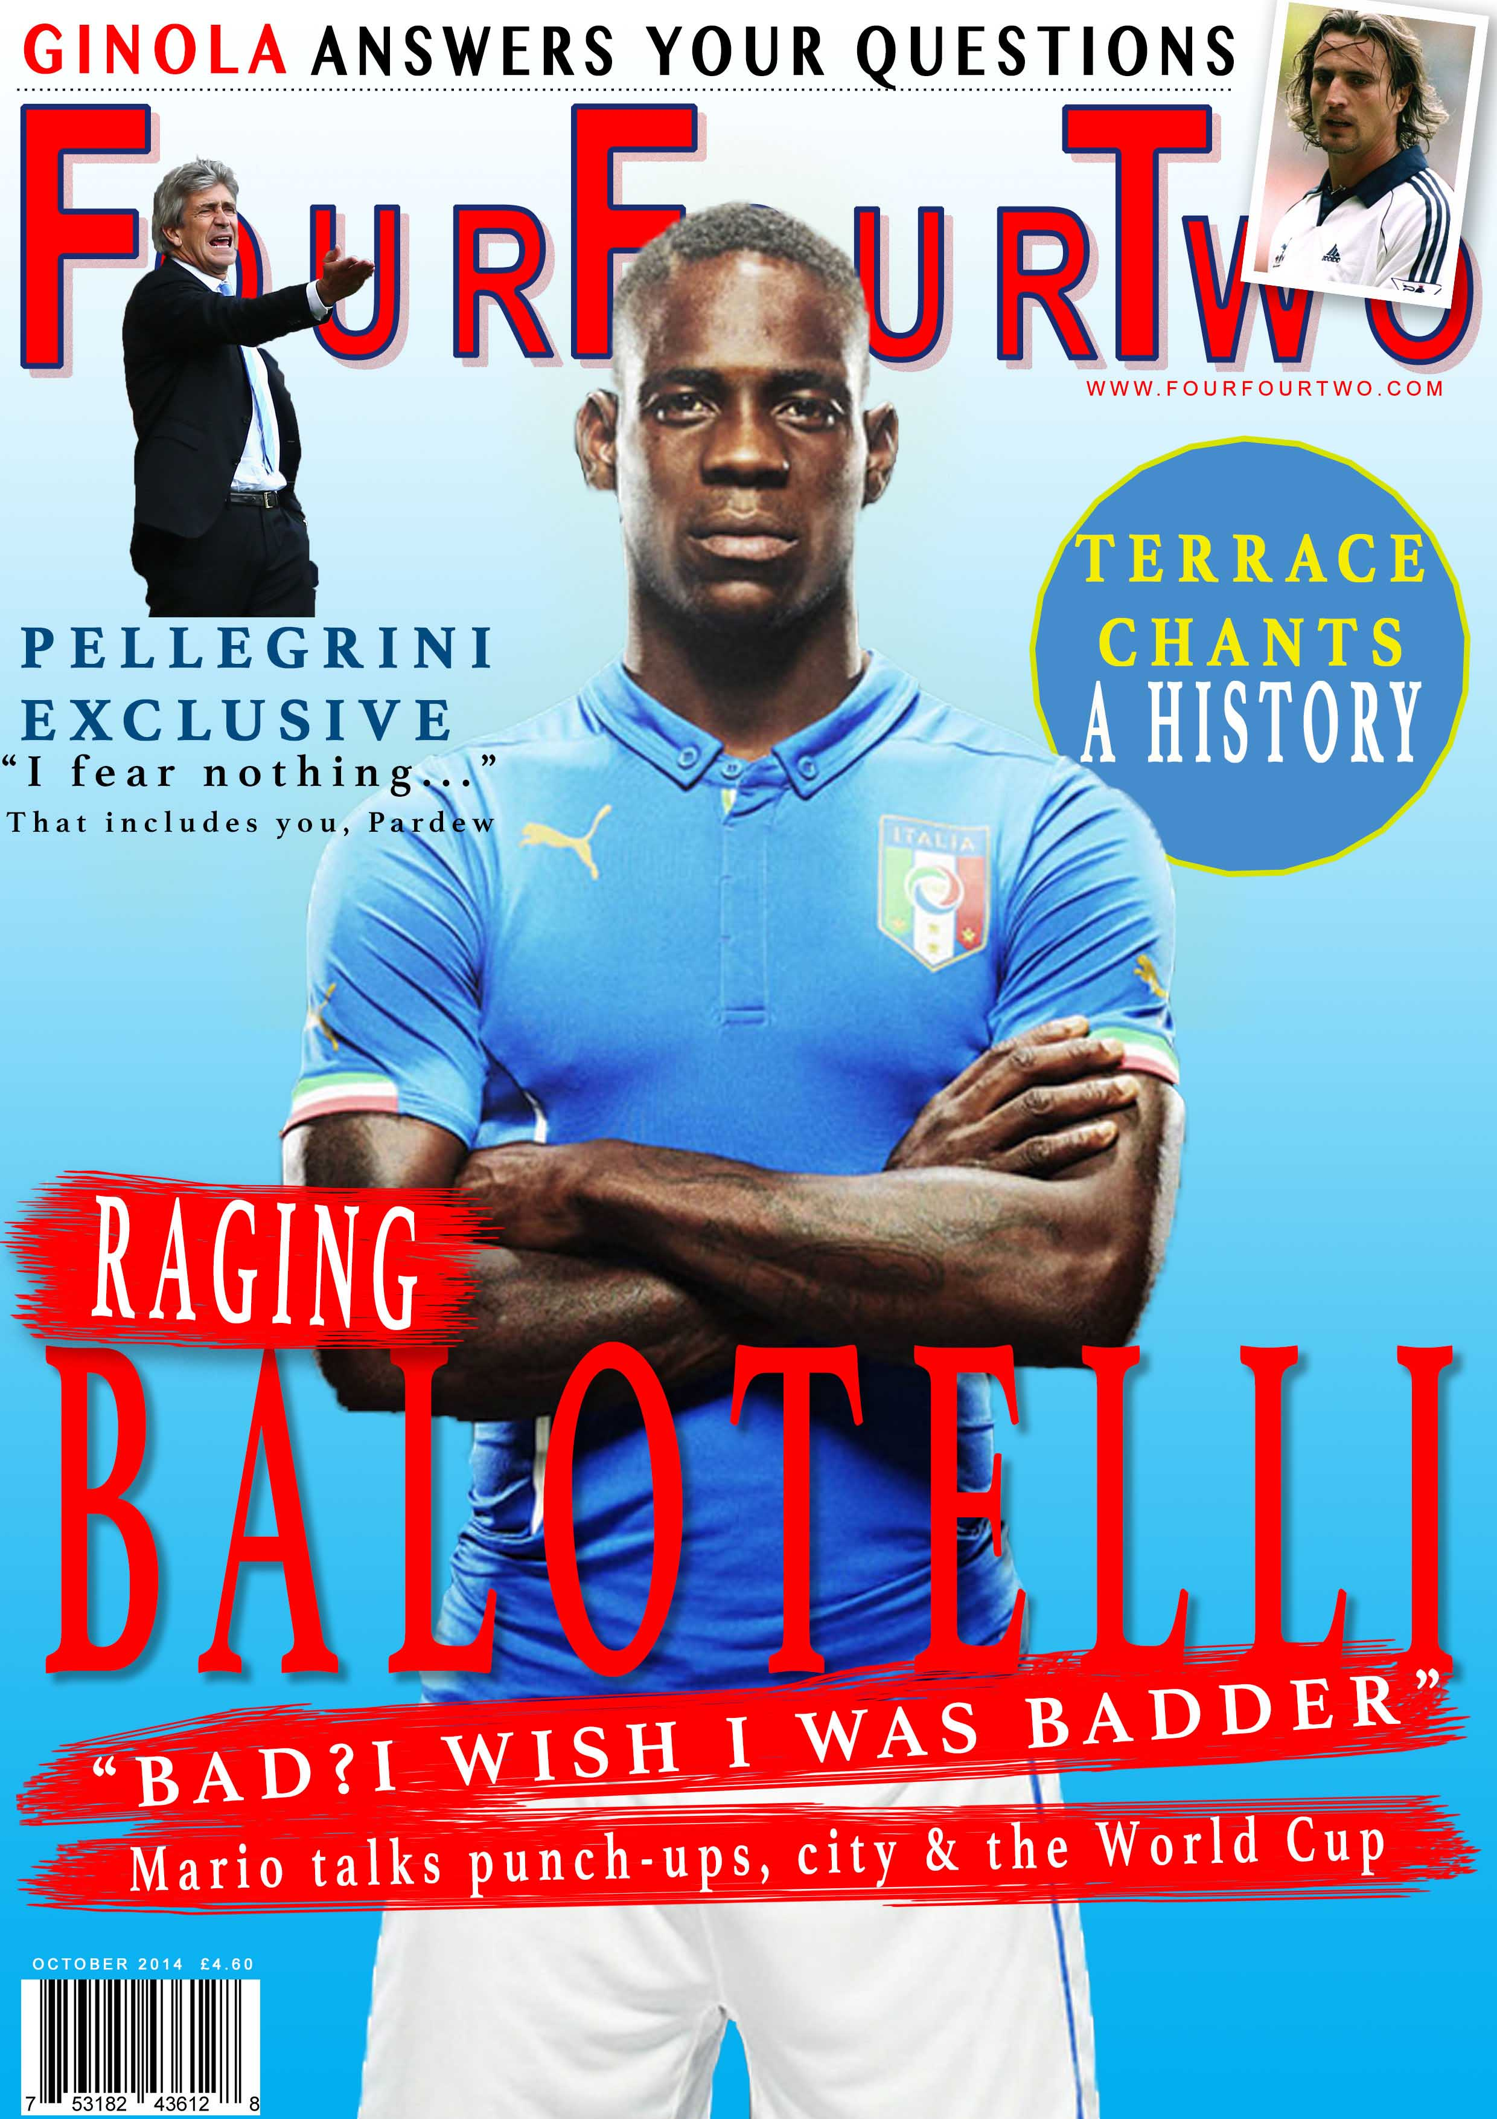

Photoshop Tutorial – Essential skills

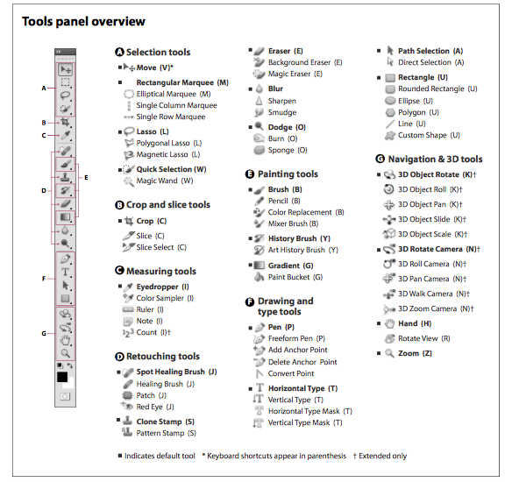
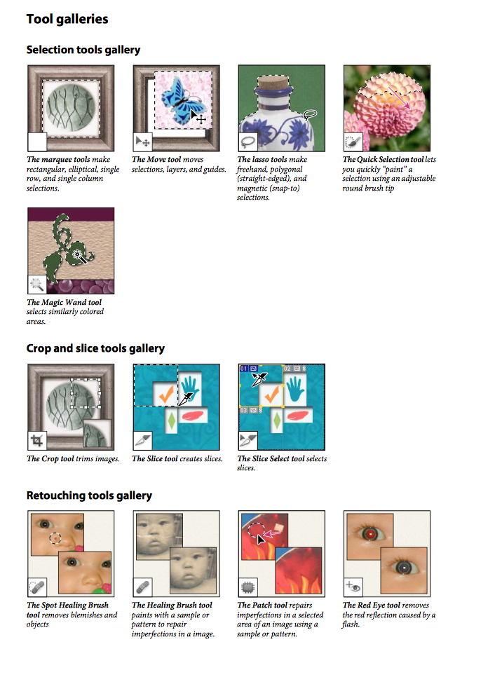
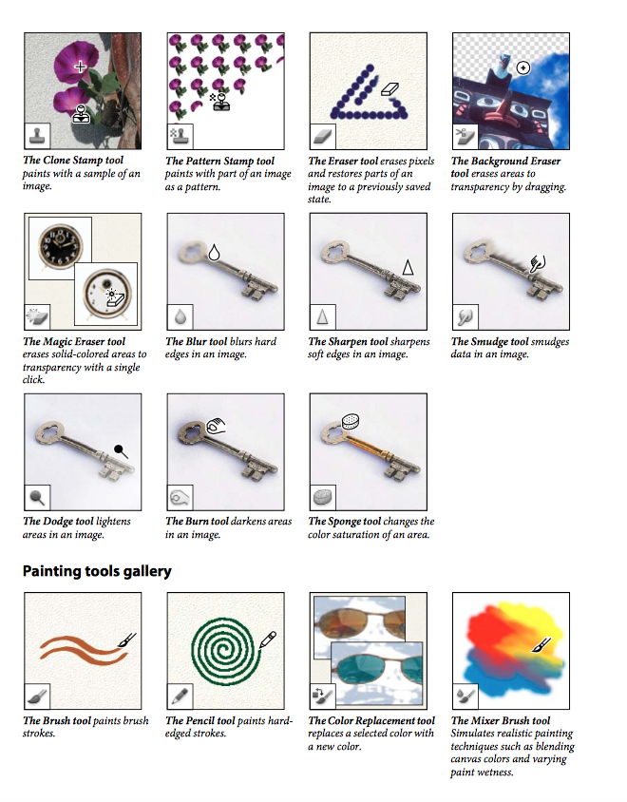
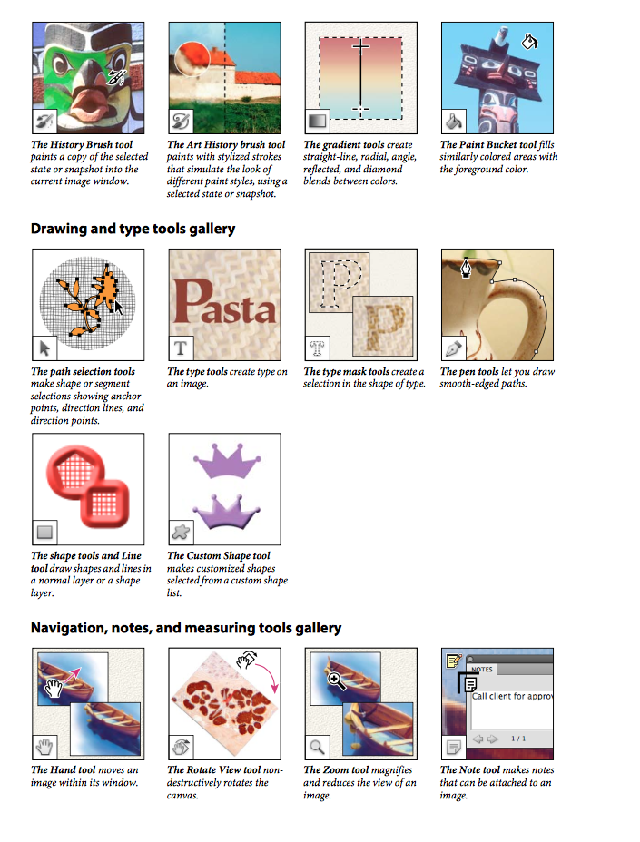
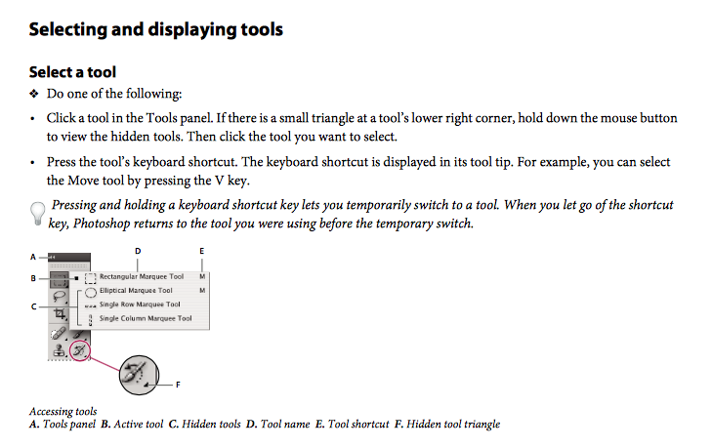

Making a new A4 Photoshop template
STEP 1
SELECT: File – New
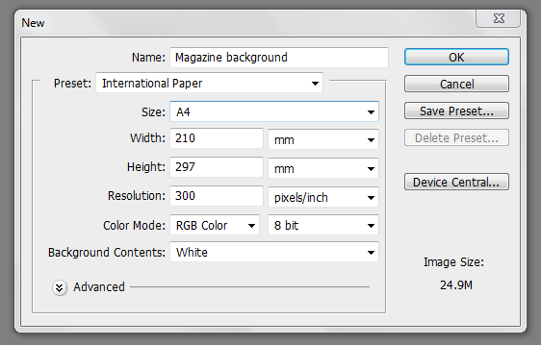
STEP 2 - Make sure your settings are the same as those in the diagram above then click OK

Your workspace should look like this

IMPORTANT – it is essential that every single element of your work is done on a separate layer and that each of those layers has a name. Also, SAVE your work regularly by hitting the save button.
Adding a colour gradient to your background
STEP 2 - Pick a colour for your gradient by clicking on the foreground colour box
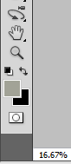
STEP 1 - Click on the gradient tool
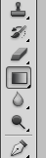
Foreground colour box
Gradient tool

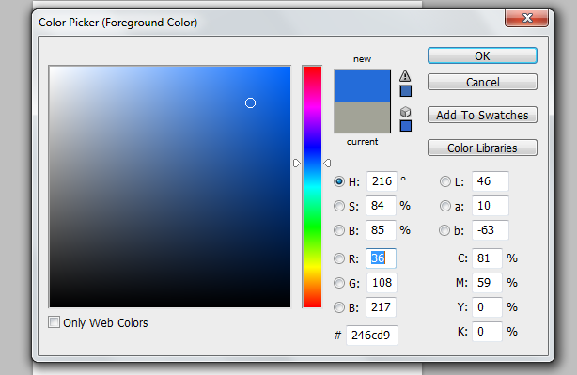
STEP 3 - In the colour picker place the cursor over the colour you want to use and click OK

STEP 4 – Select the background colour in the same way. Make sure it is different to the foreground colour.

Background colour box

Step 5 – Place the cursor at the bottom of your template and drag towards the top of the page making sure you keep the line straight. When you get to the top of the page, release the cursor.
Your template should now look like this. The dark area of the gradient will be in the colour you selected for the foreground colour. The light area will be in the colour you selected as a background colour.

Adding a colour wash to your to your background

STEP 1 – Select the paint bucket tool by holding down the gradient tool. From the pop-up, select the Paint Bucket Tool.
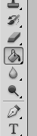
Paint Bucket Tool
STEP 2 – Select the foreground colour in the same way you did when adding a colour gradient.

STEP 3 – Hold the paint bucket tool over your template and right click your mouse.

Your template should now look like this in the colour you selected for a foreground colour.

Finally, make a new folder in your GCSE Media folder and call it ‘Poster Coursework Photoshop project’. Save your background into this folder as a Photoshop .psd to do this go to - file - save as

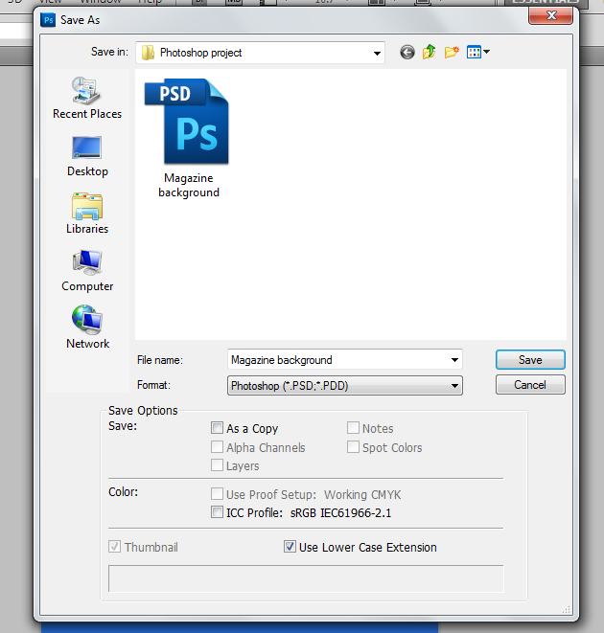
Make sure you save the file as a Photoshop .psd
In the Save As box call your file ‘Poster background’

Once you have saved your background close it by going to - file - close

Cutting out an image in Photoshop.

STEP 1 – Open the image you want to cut out in Photoshop by going to – file – open then browse for the image you want to work with. You can also find your image and then drag it into the Photoshop workspace.
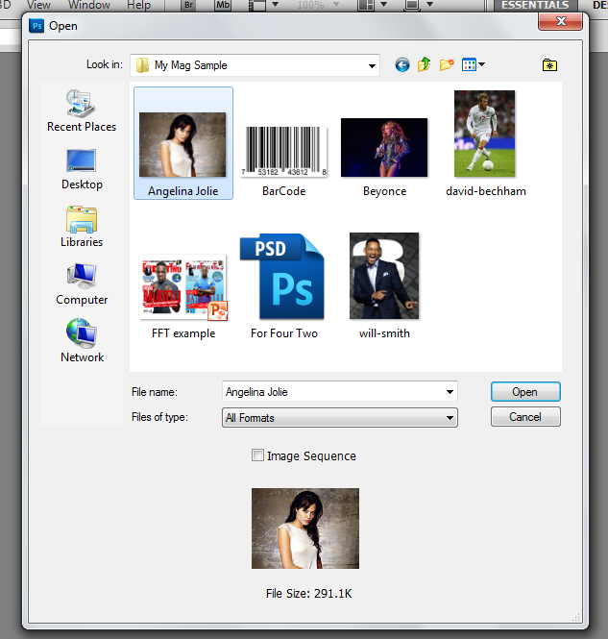
In the open dialogue box browse for the image you want to work with. When you have found it select the image and click open.
The image will open in the workspace.
Remember you can make the image bigger and smaller by pressing Control + or -
STEP 2 – Once the image is open you need to make a new background layer. Do this by going to Layer – New – Layer from background.

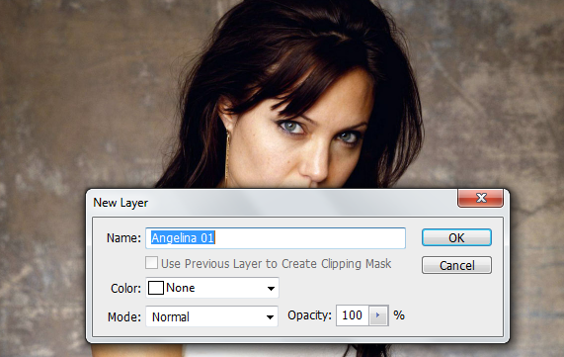
Give your new layer a name

Make sure that colour is set to ‘None’ and Mode is set to ‘Normal’ and opacity is set to ‘100%’. Then hit OK.

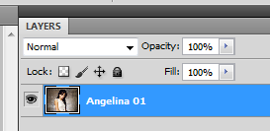
Your image will appear in the layers panel.

STEP 3 - Select the quick selection tool from the tools panel.
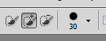
Make sure the brush size is set to 30
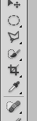
If the quick selection tool is not displayed, hold down the magic wand tool 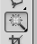 and select the quick selection tool from the pop-up.
Quick Selection Tool

STEP 4 – Hold down the right button on your mouse and move the cursor around the area you want to remove. Do this until the whole area is selected.

Make sure the whole of the area you want to remove is selected.

STEP 5 – Once you have selected the area to be removed hit the backspace button.
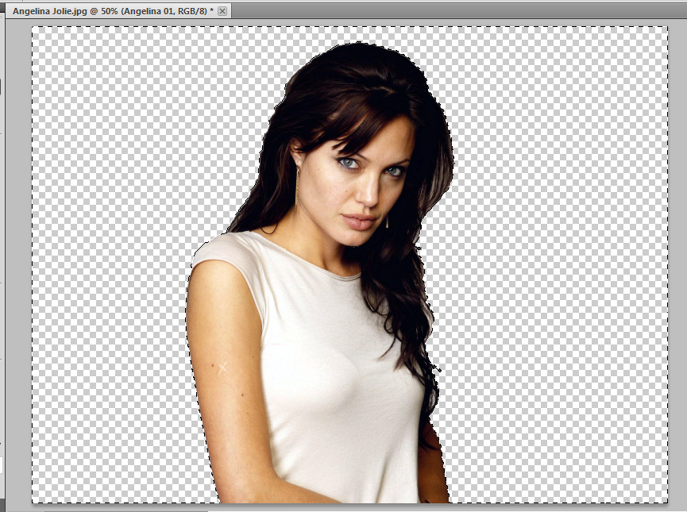
The area you selected will be removed from the image.
STEP 6 – Go to select then hit de-select. The moving dotted line around the image will now disappear.
STEP 7 - select file - Save As and once again save the image as a Photoshop .psd into your ‘Magazine course work Photoshop project’ folder. Do not close the image.

Adding the cut-out image to your background

STEP 1 - Select file – open and navigate to your ‘Poster Coursework Photoshop project’ folder. Select your background image and hit open.
STEP 2 – Select window – arrange – float all in windows. The two images you have open will now both be viewable in the Photoshop workspace.
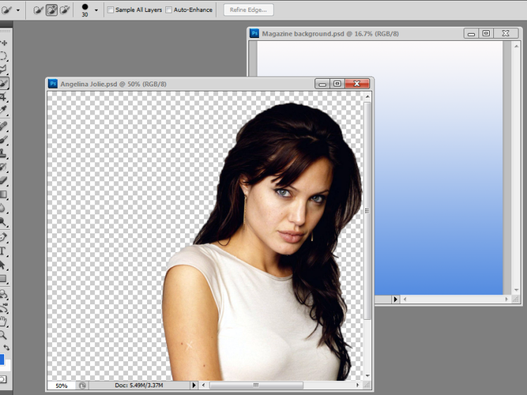
Your background and cut-out image will be viewable in the Photoshop workspace.

STEP 4 – select the Move Tool.
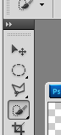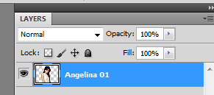
Make sure the cut-out image layer is selected. Do this by simply clicking on the layer.
Move Tool

STEP 5 – Hold the cursor over the cut-out image, right click and drag the image on to the background.
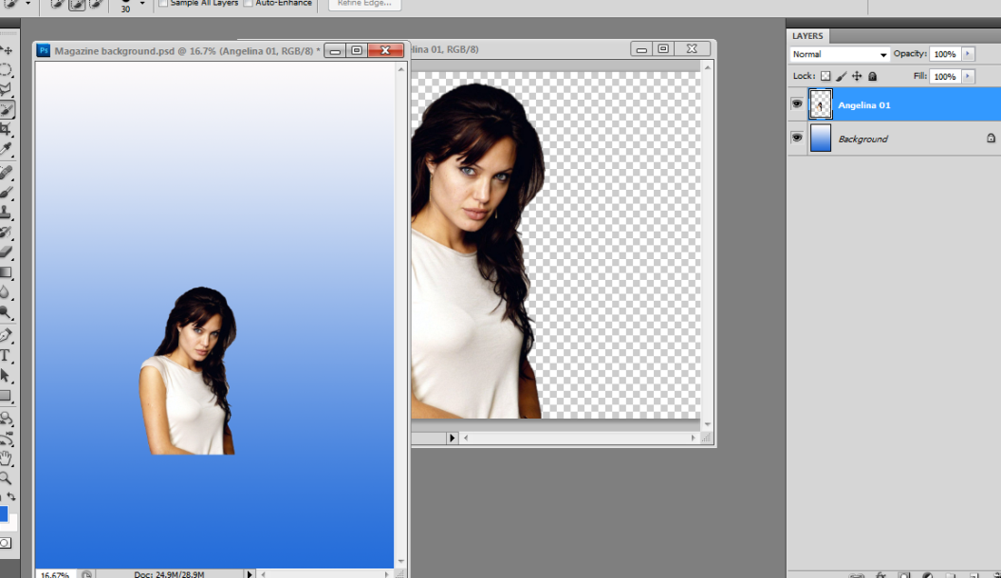
You now have two layers in the layers panel.
The cut-out image now appears on top of the background.
STEP 6 – You can now close the cut-out image.
STEP 7 – Press the F key. Your work should now appear surrounded by a grey workspace.
STEP 8 – Make sure your cut out image is selected in the Layers panel. Select Edit – Transform – Scale. A box will appear around your cut-out image.

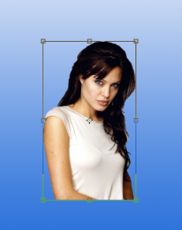
A box appears surrounding your cut-out image.

STEP 9 – Whilst holding down the shift key grab one corner of the box around your image and pull towards the edge of your workspace. Your image will get bigger.
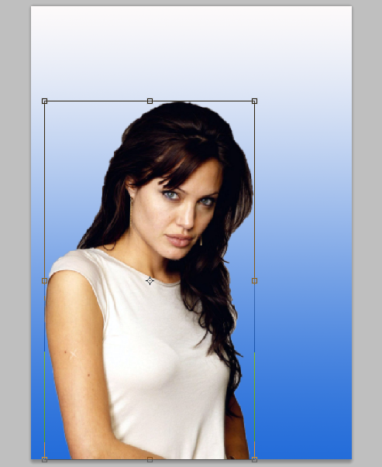
You can also use the cursor to re-position your cut out image and place it in an appropriate place for a magazine front cover. Simply right click the cursor over the cut-out image and you will be able to move it around the page.

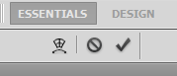
STEP 9 – On the top right hand side of your workspace there is a tick icon. Click this to confirm that you are happy with the size and position of your image. The box around your image will disappear.

STEP 10 – Select File – Save.

***USE THIS METHOD TO ADD ALL IMAGES TO YOUR
WORK INCLUDING THE BBFC SYMBOL***

Adding Text to your Film Poster

STEP 1 – Select the ‘Text’ tool from the tools panel.
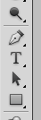
Text Tool
STEP 2 – In the font type and size panel, select the font you want to use for your film title.
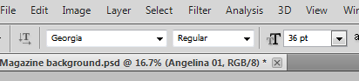

STEP 3 – Choose the colour of your text by clicking on the foreground colour box and selecting the colour you want to use from the colour picker. When you have chosen your colour click OK.
STEP 4 – Click the cursor on your workspace. A blinking cursor will appear and you can now start typing. Type the name of your masthead.
When you see the blinking cursor start typing

STEP 5 – Make sure that you have given this text layer a name in the layers panel. To do this simply double click the text in the layer and type in the name.
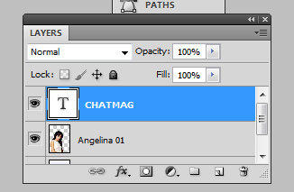

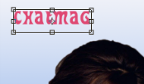
STEP 6 – Select Edit – free transform.
The transform box appears around your text. You can now re-size and position your text.

STEP 7 – Make sure the text layer is selected in the layers panel.
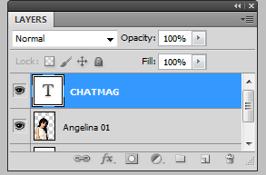
Re-size and position the text on your film poster in the same way you re-sized and positioned your cut-out image. You can fine-tune the positioning of your text using the tab keys on your keyboard.

STEP 8 – When you’re happy with the size and positioning of your film title click the tick icon.
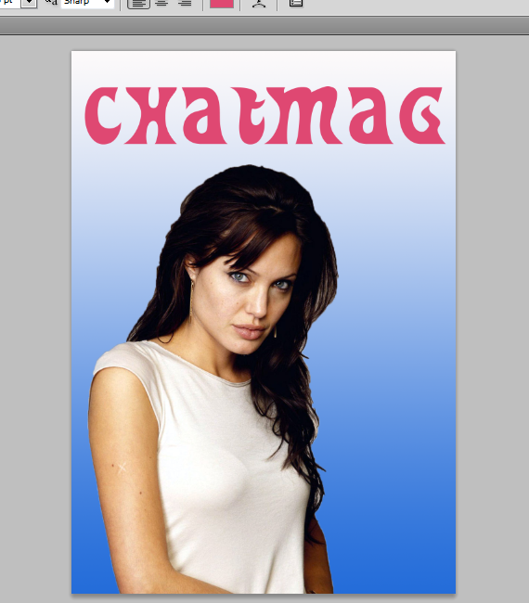

Adding simple effects to your text.
Drop shadow

STEP 1 – Make sure that the layer you want to work with is selected.
STEP 2 – Click on the FX button and from the pop-up menu select the type of effect you want to use. First click on the drop shadow effect.
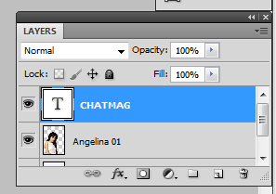
The FX button

STEP 3 – Adjust the settings in the Drop Shadow effects panel to achieve the desired results. Feel free to experiment with this.
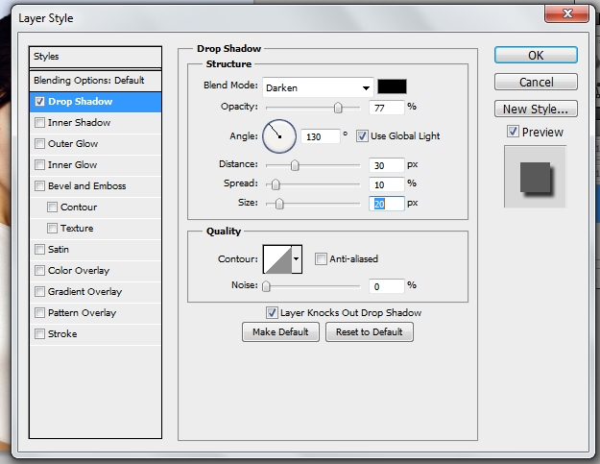
You can adjust the angle of your shadow by experimenting with the angle control
You can adjust the depth and size of your shadow by experimenting with the distance, spread and size controls
You can choose how dark your shadow is by adjusting the opacity
You can choose the colour of your drop shadow by going to the colour picker.

***REMEMBER, AS YOU MAKE ADJUSTMENTS THE EFFECTS
WILL BE VISIBLE ON THE TEXT IN YOUR WORKSPACE***
STEP 4 – When you are happy with your drop shadow effect click OK
STEP 5 – The effect will now appear in your text layer panel.
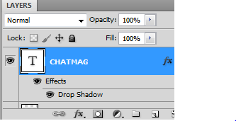

STEP 6 – If you want to add the same effect to other text layers on your film poster, simply hold down the alt key on your keyboard and drag the effect from the film title layer to the layer you wish to add the effect to.
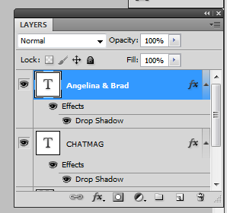
The layer effect is automatically added to the new text.

STEP 7 – If you want to alter the drop shadow on the new text, make sure the new text layer is selected and double cick on the words ‘Drop Shadow’ in the layers panel. The Layer Style box will appear . Use the controls to adjust your shadow.

Adding a coloured border (Stroke) to your text

STEP 1 – Make sure the layer you want to work with is selected in the layers panel.
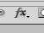
STEP 2 – Click on the FX button in the layers panel and select ‘Stroke’ from the pop-up menu. The layer style box will appear

STEP 3 –
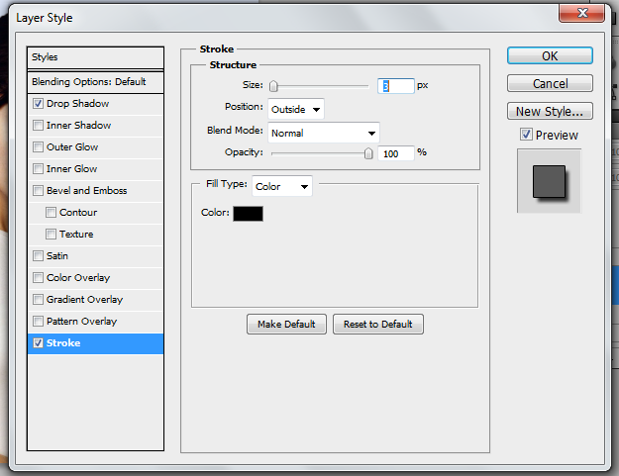
Use the opacity to control to alter how dark the border is
Use the size control to alter how thick you want your border to be
Use the colour picker to make the border the colour you need for your text

STEP 4 – Experiment with the controls until you have the desired effect. Again you will see the effects on the text in your work as you experiment. When you are happy with the results click OK

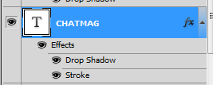
STEP 5 – The new effect will now appear in the layers panel.

You can now start adding different elements to your film poster using the techniques we have learnt. You need to include actors (director too?), a tagline, reviews or ratings from reviews, awards won, the credit block and any other images you need. Don’t forget to experiment with different layer effects.

