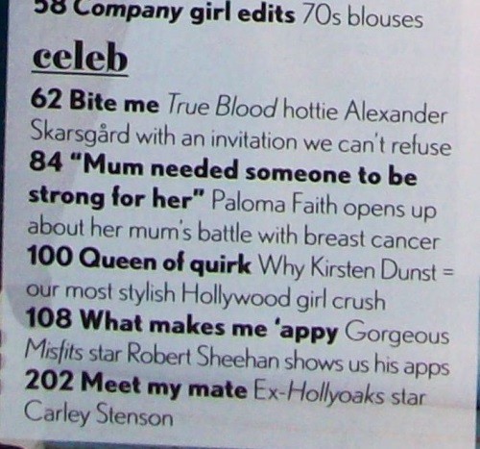
Planning my contents page
Subject heading
Article titles

- Use your brainstorming sheet about what might go in a magazine about your topic
- Think of some subject headings to group sections of articles in your magazine (eg Readers’ Stories). Now think of the titles of articles in each subject heading. Write your subject headings in the top row, then add articles underneath each one. Try to be creative with your language. Add extra columns to this table for extra subject headings.
SUBJECT HEADING | EXAMPLE:  Readers’ Stories
Article title | 7 Nasty Knitter  My ‘friend’ sent messages knitted into scarves
Article title | 32 Nifty Needles  I won the title of fastest knitter in Berkshire
Article title | 46 Pull the wool over his eyes  How I kept knitting to hide my affair
Article title
Article title
Article title
Article title

- Now write page numbers for each article (eg the first column could be pages 4, 19, 28, 65 etc, then the second column could be 7, 32, 46, etc). Notice that all of the pages in one topic are not all together in the magazine but spread over the magazine)

